AGENDA
Fish Passage O&M Coordination (FPOM) Team
October 06, 2009 (0900-1300)
St. Helens Room, NOAA Fisheries, Portland, OR

Conference line: 888-830-6260 FPOM code: 960904 Klatte/Dykstra code: 855808

- Review/Approve Agenda and September Minutes (Dykstra)

- Action Items
  - [Jun 09] BON spillway repairs. ACTION: Lee will provide updates to FPOM.
  - [Sep 09] LGS spillbay weir. ACTION: Dykstra will task Planning with doing the analysis of the benefits of the RSWs to sub-yearlings, as requested by FPOM.
  - [Sep 09] TDA ITS operation. ACTION: Fredricks will send Mackey a copy of his handout regarding TDA ITS operation for inclusion in the minutes. STATUS: completed on 23 September.
  - [Sep 09] LGS spillbay weir. ACTION: Mackey will listen to the August meeting and determine which study Dykstra needed to send. STATUS: completed.
  - [Sep 09] BON AFF minutes. ACTION: Mackey will better define the short-term issues for FPOM in October. STATUS: completed and included with this agenda on page 16.
  - [Sep 09] NWW winter maintenance schedules. ACTION: NWW will provide winter maintenance schedules for the October FPOM. STATUS: covered in 3.9
  - [Sep 09] BON FVB roof. ACTION: Sawka will get more construction details and bring it back to FPOM in October. STATUS: covered under 4.0

- Updates. (Klatte/Dykstra)
  - BON Fish unit trashrake. Update on test.
  - BON Bay 15 hoist. Rerecich to confirm the repairs will be complete by March 2010
  - BON TIE Crane. Update on the status of the boom.
  - BON CI velocity measurements. Update on why the data is needed now and how it will be used. Currently scheduled for 27 October.
  - BON jumping fish at the vertical slot PIT tag detectors.
  - BON B2CC avian array.
  - JDA avian array. Update from the 21 Sept mtg and 23 Sept LRAD demo.
  - TDA ITS test operation. Update on whether a proposed test has been agreed to.
  - NWW winter maintenance schedules. (pages 4-5)
  - MCN fish pumps. Update on the potable water repairs.
  - MCN lamprey modifications. FPOM wanted further discussion about the orifices NWW wants to cut into the weirs.
  - MCN and LMN - End of truck transport
  - LMN juvenile fish condition update
  - LGS and LWG - Discuss continuation of truck transport

- BON WS FVB roof replacement. Sawka will provide construction details.

- BON PH1 fish screens. The Project would like official word that the screens may be scrapped once they are pulled this year.

- BON Ambursen section in-water work. (page 6) NWP will be filling the Ambursen section with concrete. The Ambursen team would like to discuss the proposed work and coordinate any extension to the in-water work period, if necessary.
  - If the contractor chooses to mix and pump concrete from a barge (this is not expected since there is a concrete plant not far from Bonneville) there will be, potentially, round the clock noise associated with concrete mixing and pumping, and generators used for lighting.
  - If the contractor chooses to bring concrete in by truck, there will be the noise associated with pumping the concrete from the roadway.
  - There will also, potentially, be a barge crane used to move equipment and scaffolding in and out of the Ambursen section. The barge crane would be used intermittently and during normal work hours.
  - The proposed location of the barges can be seen on the attached drawing. This is very close to the intake for FV1-1 but not close to any fish passage entrance or exit.
  - Work could take from 6 months to a year.

- Smith-Root study proposal.
  - Testing of DIDSON in the UMT (page 7). Smith-Root and USGS would like to test the DIDSON in the UMT prior to installation of the sea lion array. They need to determine if they can get the information they are after from a DIDSON. At this time, they do not anticipate using the UMT count window.

- TDA sluiceway outage for transducer installation. 27 October has tentatively been planned as a dive day to fix any bad transducers on the powerhouse. As of recently, all the powerhouse transducers are working ok. If there is not a need to dive on 27 October, PNNL would like to use that day to install transducers for the sluiceway. If there is a dive, PNNL would like to install the sluice transducers on 28 October. The sluice transducers will be installed on the piers of MU 1, MU 5, and MU 18, by boat and from the deck. Because some work will be conducted from a boat (a safety boat will be on location), PNNL requests the sluiceway be closed and main units adjacent to the mentioned sluices in the following order:
  - Sluice 1: FU2, MU1, MU2 offline for about 2 hours. Sluice 5: MU4, MU5, MU6 offline for about 1 hour. Sluice 18: MU17, MU18, MU19 for about 2 hours
  - If there is diving, the units of the dives and adjacent units will have to be offline.

- Galvanized grates. Cordie wanted to know when a final decision will be made and wanted to add to the discussion, the zebra mussel deterrent properties of zinc.

- JDA spillbay 2 outage for maintenance. Coordination form on page 8

- JDA spillbay 2 outage for PNNL. PNNL and JDA request closing spillbay 2 on 10/21 for PNNL's transducer removal. PNNL crew would prefer to schedule this outage 0800-1400 and the entire spillway will need to be cleared for safety of their boat working in the forebay. Due to timing of this outage and its short duration of only 6 hours (maximum, possibly 4 hrs), an impact on adult fish passage is expected to be minimal.

- Adult fish passage data and website display of nighttime counts

- MCN and IHR Lamprey – Velocity reduction status (Fryer)

- LGR adult fish trap water supply – replace butterfly valve.

- LGS dewatering tower and outfall pipe extension

- LGS ROV inspection of NPE-3. Coordination form on page 9

- 2010 FPP change forms to be approved or rejected. (page 14-15)
  - 10BON002- 2.1.2 split flows for fish- minimum flow requirements.
  - 10MCN003- 2.3.1.2.b.1 Delay of ESBS installation
  - 10LMN002- 4.3.1 Turbine headgate and cylinder removal

- Potential 2010 FPP changes (change forms not yet drafted).
  - BON unit priority for high head. This is to address the issue with trying to maintain the 1% criteria when using only PH2 units during high head events. At least one PH1 unit needs to be operated to allow enough flexibility for units to operate within the 1% band without pushing against the upper or lower limits.
  - BON PH1 unit priority. This was a new issue brought up at the September meetings. With the removal of the ITS wall, the unit priority may change.
  - MCN temperature triggers. Lorz to draft the form and send to Moody.
  - LGS spillbay weir triggers at low flow.
  - Appendices J and K temperature criteria. These changes will detail the temperature protocols for what is actually happening. Fredricks had asked for this clarification last year, but the language didn’t get drafted prior to FPP printing. Martinson will send his proposed language to Rerecich.

- Other
  - JDA south fish turbine #2. Two dives in the summer 2010.

- Remaining 2009 FPOM Meetings
  - November 12 2009 from 1000-1400 at NOAA Fisheries in Portland.
  - December FPOM – 08 Dec (Tuesday) 0900-1300 at NOAA Fisheries in Portland. Proposed date change due to SMP meeting scheduled on 9-10 Dec.
Adult Fish Passage Facilities – 2009-10 Winter Maintenance Schedule
U. S. Army Corps of Engineers- Walla Walla District

MCNARY DAM - Washington Shore Fishway
- Dewater the WA fish ladder from January 19 to February 15 for maintenance. Complete winter maintenance according to the Fish Passage Plan, Section 2.3.2.1.
- Inspect the collection channel by dewatering the diffuser gratings and lower junction pool.
- Perform maintenance on the small hydro bypass and auxiliary water supply system.
- Maintain adult PIT tag system as required. Coordinate with PSMFC.
- Maintain half-duplex PIT (lamprey) antennas. Coordinate with University of Idaho.
- Resume normal operation of the ladder and small hydro/auxiliary water system by February 15.

MCNARY DAM - Oregon Shore Fishway
- Shut down AWS pumps 1, 2, and 3 at sundown on December 31 and place ladder in orifice flow.
- Dewater the fish ladder from January 4 to February 28 for extensive maintenance on fish pumps, auxiliary intake traveling screens at ladder exit, and installation of fish exit stop log guides and lamprey passage improvements.
- Complete winter maintenance according to the Fish Passage Plan, Section 2.3.2.1.
- Inspect the collection channel by a combination of underwater video or diving. ¹
- Perform routine winter maintenance on all three AWS fish pumps, and dewater fish pump number 1 for inspection and maintenance.
- Maintain adult PIT tag system as required. Coordinate with PSMFC.
- Resume normal ladder flow and 2 pump operation on February 28.

ICE HARBOR DAM - North Shore Fishway
- Shut down the AWS pumps on January 22
- Dewater the fish ladder from January 26` – February 23 for maintenance.
- Complete winter maintenance according to the Fish Passage Plan, Section 2.3.2.1.
- Inspect the collection channel by underwater video. ¹
- Perform maintenance on the AWS pumps.
- Maintain adult PIT tag system as required. Coordinate with PSMFC.
- Resume normal operation of the AWS pumps on February 23.

ICE HARBOR DAM - South Shore Fishway
- Shut down the AWS pumps on the morning of January 1.
- Dewater the fish ladder from January 5 – 19 for maintenance.
- Complete winter maintenance according to the Fish Passage Plan, Section 2.3.2.1.
- Unwater and Inspect the collection channel by visual inspection. ¹
- Perform maintenance on the AWS pumps.
- Maintain adult PIT tag system as required. Coordinate with PSMFC.
- Maintain half-duplex PIT (lamprey) antennas. Coordinate with University of Idaho.
- Resume normal operation of the AWS pumps on January 19.

LOWER MONUMENTAL DAM - North Shore Fishway
- Shut down the AWS pumps on the morning of January 1.
- Dewater the fish ladder from January 4 - 15 for maintenance.
- Complete winter maintenance according to the Fish Passage Plan, Section 2.3.2.1.
- Inspect the collection channel by dewatering. See Table 1.
- Perform maintenance on the AWS pumps.
- Resume normal operation of the AWS pumps on January 19.

LOWER MONUMENTAL DAM - South Shore Fishway
- Dewater the fish ladder from January 20 – February 27 for maintenance.
- Complete winter maintenance according to the Fish Passage Plan, Section 2.3.2.1.
- Inspect the collection channel by dewatering. See footnote on page 1.
- Refurbish FSQ-1, control cabinet and update electronics, for lower south fish ladder.
- Remove isolation points and water up south ladder on February 27.

LITTLE GOOSE DAM
- Shut down the AWS pumps on the morning of January 1.
- Dewater the fish ladder from January 5 – February 25 for maintenance.
- Replace NPE3 and NSE3 Bulkheads (January).
- Dewater collection channel from February 1 – 24.
- Complete winter maintenance according to the Fish Passage Plan, Section 2.3.2.1.
- Inspect the collection channel by dewatering. See Table 1.
- Maintain adult PIT tag system as required. Coordinate with PSMFC.
- Perform maintenance on the AWS pumps.
- Inspect and repair the adult fish fallout fence, and diffusers gratings.
- Re-lamp light fixtures in adult channel.
- Resume normal operation of the AWS pumps on February 25

LOWER GRANITE DAM
- Shut down the AWS pumps on the morning of January 1.
- Dewater the fish ladder from January 4 – February 23.
- Complete winter maintenance according to the Fish Passage Plan, Section 2.3.2.1.
- Inspect the collection channel by dewatering.
- Perform maintenance on the AWS pumps. Repair / replace picketed leads.
- Maintain adult PIT tag system as required. Coordinate with PSMFC.
- Inspect the adult fish fallout fence and diffusers.
- Inspect and repair areas within the adult fish trap.
- Resume normal operation of the AWS pumps on February 23.

Table 1. Methods used to inspect adult fishway collection channels during past winter maintenance periods, compared to the upcoming winter period.
 | 2004-05 | 2005-06 | 2006-07 | 2007-08 | 2008 -09 | 2009-10
MCN WA Shore | Dewatering | Dewatering | Underwater video | Dewatering | Dewatering | Dewatering
MCN OR Shore | Underwater video or diver? | Underwater video or diver | Dewatering | Video and dive | Dewatering | Dewatering and Video
IHR N Shore | Underwater video | Dewatering | Underwater video | Underwater video | Visual Dive Inspection | Underwater video
IHR S Shore | Underwater video | Underwater video | Dewatering | Underwater video | Underwater video | Dewatering & Inspection
LMN N Shore | Dewatering | Dewatering | Dewatering | Dewatering | Dewatering | Dewatering
LMN S Shore | Dewatering | Dewatering | Dewatering | Dewatering | Dewatering | Dewatering
LGS | Underwater video | Dewatering | Underwater video then dewatering | Dewatering | Dewatering | Underwater video
LWG | Dewatering | Dewatering | Dewatering | Underwater video | Dewatering | Dewatering

BON Ambursen section- Proposed location of Contractor’s barge.
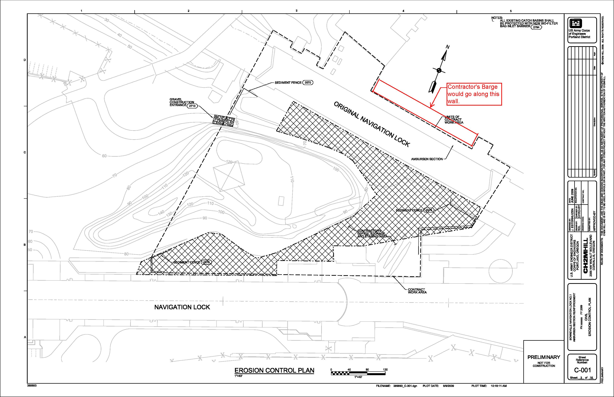
OFFICIAL COORDINATION REQUEST FOR
NON-ROUTINE OPERATIONS AND MAINTENANCE

COORDINATION DATE- 1 October 2009
PROJECT- Bonneville Dam
RESPONSE DATE- 06 October 2009
Description of the problem- Smith- Root, Inc. is working with the USGS – BRD (i.e., Matt Mesa) to evaluate the efficacy of a non-lethal sea lion deterrence array. The group proposes to evaluate the deterrence array in the UMT at BON Powerhouse 2. Fish behavior is proposed to be recorded through the use of a DIDSON acoustic camera. To avoid adverse hydraulic effects of mounting the DIDSON in the UMT, the researchers are proposing to deploy the DIDSON from a small raft floating in the UMT during the duration of the study.
Prior to initiation of the study, the researchers need to verify the field of view for the DIDSON to assure adequate monitoring can be accomplished. To accomplish this objective, the DIDSON camera will be mounted the bottom of a small pontoon raft. This assembly will then be lowered into the UMT. Researchers will then verify the field of view for the DIDSON. Observations on fish behavior in the vicinity of structure will also be made.
Type of outage required- No outage requested.
Impact on facility operation- No impacts.
Length of time for repairs- No more than one day. This work is proposed to be scheduled the week of October 12.
Expected impacts on fish passage- Minimal. The raft measures approximately 6 feet long by 3 feet wide. The raft is expected to extend into the water column (i.e., draft) less than two inches. The DIDSON is about one square-foot in size. The camera will be installed to the underside of the raft. The camera is expected to draft less than 8-inches. Earlier proposals considered mounting the DIDSON on the bottom or sides of the UMT. This installation will reduce any hydraulic impacts.
Installation will require no interruption of facility operation. The raft and camera assembly will be lowered by hand into the UMT. The assembly will then be secured by ropes through the duration of the evaluation. The assembly will be removed immediately after completion of the necessary testing.
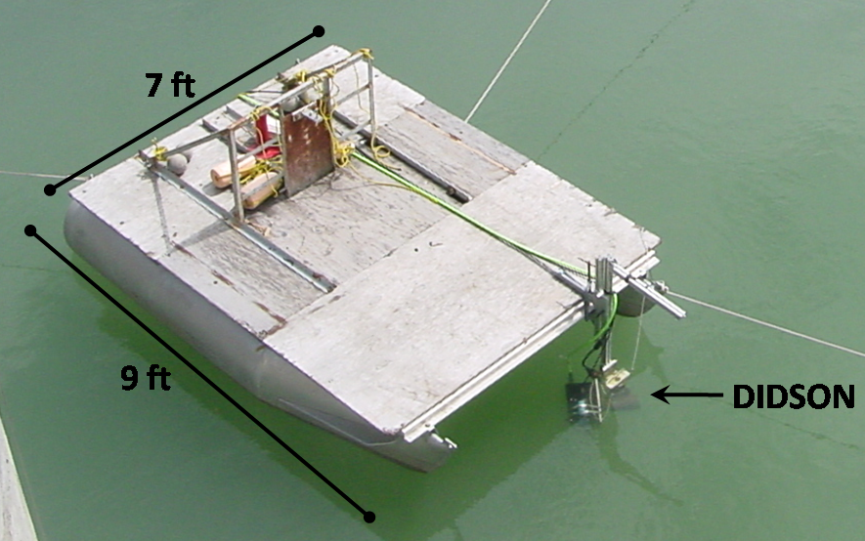
Comments from agencies
Final results
Please email or call with questions or concerns:
Shane Scott (on behalf of Smith Root, Inc and USGS – BRD)
Cell: (360) 601-2391 sscott06@earthlink.net
OFFICIAL COORDINATION REQUEST FOR
NON-ROUTINE OPERATIONS AND MAINTENANCE

COORDINATION DATE- 28 September 2009
PROJECT- John Day Dam
RESPONSE DATE- 06 October 2009

Description of the problem- According to FPP, JDA spill bay 2 is required to be on during daylight hours at one stop (1.5 Kcfs) for attraction of adults to north ladder’s entrance through October. JDA maintenance needs half day outage for tri-annual maintenance of tainter gate ASAP. This work is required to be performed during dry and warm weather so it can’t be postpone till winter outage and it will be the last gate done this year.

Structural crew has graciously agreed to stay after hours to minimize impact on fish passage. Also, Operations is proposing to substitute for bay2 with 1.5 kcfs spill from bay 1 or 3 during this outage, if necessary.

Type of outage required- spill bay 2 closed for maintenance.

Impact on facility operation- attraction flow would be limited for about five hours from 1400 until 1900 in early October.

Length of time for repairs- About five hours. The Structural crew has agreed to work late afternoon to early evening to minimize impacts to fish passage.

Expected impacts on fish passage- Attraction flow to the north ladder will be off for about five hours. Bay 1 or 3 will be used to compensate for flow.

Bay 1 showed long retention times for dye, which could result in poor evacuation for juveniles, however, the spill at this time of year is for adult attraction instead of juvenile passage.

Bay 3 could be used to compensate flow but that bay if further from the fishway entrance and may not provide the same adult attraction as a closer bay would.

Due to short duration, PM timing and substitution spill, an impact on passing adults is expected to be minimal.

Comments from agencies

Final results

Please email or call with questions or concerns.
Thank you,
Tammy Mackey
NWP Operations Division Fishery Section
Columbia River Coordination Biologist
541-374-4552 Bonneville Office or 503-961-5733 Blackberry
Tammy.m.mackey@usace.army.mil

COORDINATION DATE- September 30, 2009
PROJECT- Little Goose Lock and Dam
RESPONSE DATE- October 6, 2009 FPOM meeting.

Description of the problem: North Powerhouse Fish Entrance #3 (Concrete Bulkhead - normally closed) has deteriorated. Due to spill forces, the concrete and rebar reinforcement has broken from is steel frame and the condition of the underwater portion of the bulkhead is unknown. The integrity of bulkhead needs to be inspected using a remotely operated vehicle (ROV) and camera prior to removal and replacement.

Inspection is required to determine repair procedures and scheduling (i.e. divers may be required and a floating platform with crane may be required). To ascertain this information as soon as possible will be beneficial to the successful completion during the end if the winter maintenance period.
The top 1/3 of the NPH-3 bulkhead needs visual inspection. This upper part appears to be damaged and may have a problem with clearance during the removal. The ROV inspection will evaluate the integrity and assist in determining if any part of the structure is in the way of removal. If there are structural elements in the way of removal, this inspection will give needed time to contract a dive during removal of the bulkhead during winter maintenance.

Type of outage required: Shut down all three auxiliary fish pumps and close off NPE1 & 2 and NSE 1 & 2 to reduce flows and hydraulic forces that would prevent the use of the ROV. Total down time on one day requested is 6 hours 0900 to 1500 hours during the week of November 30 or after.

Impact on facility operation: Two of the three fishway entrances will be closed and all three fish pumps will be shut down. This is peak period for Fall Chinook passage however we are unable to obtain the ROV and personnel to operate it at an earlier date.
Spill and TSW operations will have ended and appropriate safe work clearances will be in place to perform the work.

Length of time for repairs: ROV inspection is expected to be complete in 6 hours. If a new bulkhead is on site replacement may add an additional 2 hours.

Expected impacts on fish passage: It is estimated the 67% of adult fish passage efficiency will be lost during the inspection.

Comments from agencies
During the August 20, 2009 FPOM meeting, the damage to NPE-3, and NSE-3 were introduced. FPOM agreed waiting to replace the concrete gates at NPE-3 and NSE-3 in January / February 2010.

Final results:

Please email or call with questions or concerns.
Thank you,

September 2009
Sunday | Monday | Tuesday | Wednesday | Thursday | Friday | Saturday
 |  | 1  FPAC | 2 | 3  BON PH1 STSs installed by today  NWP – FFDRWG | 4 | 5
6 | 7 | 8  FPAC  TDA spill wall work scheduled to begin | 9  TMT | 10  FPOM Meeting  TDA spillwall call | 11 | 12
13  Happy Birthday | 14 | 15  FPAC | 16 | 17  Happy Birthday | 18 | 19
20 | 21  JDA avian array mtg | 22  FPAC | 23  TMT  JDA deflector mtg  JDA LRAD demo | 24  TDA spillwall call | 25 | 26
27  Happy Birthday | 28 | 29  FPAC | 30

October 2009
Sunday | Monday | Tuesday | Wednesday | Thursday | Friday | Saturday
 |  |  |  | 1 | 2 | 3
4 | 5  MCN COP alternatives- Portland | 6  FPOM- NOAA  MCN COP alternatives (in PDX) | 7  NWW- Eonfusion demo | 8  TDA spillwall call | 9 | 10
11 | 12  HOLIDAY- Columbus Day | 13 | 14 | 15 | 16  Happy Birthday | 17
18 | 19  Happy Birthday | 20 | 21  AFEP final proposals sent  FFDRWG- NWP  NWW (in PDX)- forebay/tailrace influence for each project | 22  TDA spillwall call | 23 | 24
25 | 26 | 27  BON spillway survey  BON CI measurements | 28  FFDRWG-NWW | 29  FFDRWG- NWW | 30 | 31  Normal Adult Fish Counting Ends Most Dams  BON JMF to bypass

November 2009
Sunday | Monday | Tuesday | Wednesday | Thursday | Friday | Saturday
1 | 2  ERDC- JDA internal | 3  ERDC- JDA internal | 4  ERDC- JDA internal | 5  ERDC- JDA internal  TDA spillwall call | 6  ERDC- JDA internal | 7
8 | 9 | 10 | 11  Veteran’s Day | 12 FPOM Meeting  Input for draft FPP due. | 13 | 14
15  Happy Birthday | 16 | 17 | 18  Happy Birthday | 19  TDA spillwall call | 20 | 21
22 | 23 | 24 | 25 | 26  Happy Thanksgiving | 27  Draft FPP Due in NWD | 28
29 | 30

December 2009
Sunday | Monday | Tuesday | Wednesday | Thursday | Friday | Saturday
 |  | 1  AFEP review | 2  AFEP review | 3  AFEP review  TDA spillwall call | 4  AFEP review | 5
6 | 7 | 8  FPOM- NOAA | 9  SMP meeting | 10  SMP meeting | 11 | 12
13 | 14.  ERDC- JDA/TDA | 15  ERDC- JDA/TDA  Adult fish counting ends LWG. | 16  ERDC- JDA/TDA | 17  ERDC- JDA/TDA  TDA spillwall call | 18  ERDC- JDA/TDA | 19
20 | 21 | 22 | 23 | 24 | 25  Merry Christmas | 26
27 | 28 | 29 | 30 | 31  TDA spillwall call

FPP Change Forms
☺☺☺☺☺☺☺☺☺☺☺☺☺☺☺☺☺☺☺☺☺☺☺☺☺☺☺☺☺☺☺☺☺☺☺☺☺☺☺☺☺☺☺☺☺☺☺☺☺☺☺☺☺☺☺☺☺☺☺☺
☺☺☺☺☺☺☺☺☺☺☺☺☺☺☺☺☺☺☺☺☺☺☺☺☺☺☺☺☺☺☺☺☺☺☺☺☺☺☺☺☺☺☺☺☺☺☺☺☺☺☺☺☺☺☺☺☺☺☺☺
Change Request Number: 10BON002
Date: 9/22/2009
Proposed by: FPOM
Location of Change: BON 2.1.2
Proposed Change: include minimum flow requirements for split flow operations.
    - When adult and jack salmonid counts equal or exceed 30,000 fish/day before August 31… This operation will continue until Project fish counts fall below 20,000 fish.
      - Turbine units should be operated at the mid or upper 1% range whenever possible, during the split flows operation.
      - Split flow operations, prior to the end of summer spill, may only occur if flows exceed 110K.
Reason for Change: to provide clarity during low flow years.
Comments from others:
Record of Final Action:
☺☺☺☺☺☺☺☺☺☺☺☺☺☺☺☺☺☺☺☺☺☺☺☺☺☺☺☺☺☺☺☺☺☺☺☺☺☺☺☺☺☺☺☺☺☺☺☺☺☺☺☺☺☺☺☺☺☺☺☺
Change Request Number: 10LMN002
Date: August 20, 2009
Proposed by: Bill Spurgeon – Lower Monumental Project Biologist
Proposed Change: From: 4.3.1. …On the completion of maintenance, the turbine unit can be operated with the operating gates in the standard operating position until 0700 hours of the first regular workday after the maintenance is completed.
To: 4.3.1. …On the completion of maintenance, the turbine unit can be operated with the operating gates in the standard operating position until 1200 hours of the first regular workday after the maintenance is completed.
Reason for Change: The 0700 hours Monday deadline does not allow sufficient time to pull the cylinder. Every work day begins at 0630 hours with a morning meeting covering task assignments and issue discussions. The morning meeting typically lasts until 0700 hours leaving no time to do complete cylinder removal by 0700 hours as stated in the current Fish Passage Plan. Cylinder removals usually occur on Mondays. The proposed 1200 hours deadline not only allows time to perform the work, but also provides a modest buffer that allows personnel time to address Monday morning emergency or urgent maintenance needs that typically arise during the weekend that just ended.
Comments from others: John Bailey- NWW Operations Division: application of this change will not make much of a practical difference in turbine operations as this procedure is permitted only during the July 1 to December 15 time period when total river flow is low. The section requires at least 4 other turbine units be available for service before this procedure is allowed. There won’t be any need to operate the affected turbine unit in most cases as there won’t be enough river flow to operate 5 turbine units and meet spill requirements at the same time.
Record of Final Action:
☺☺☺☺☺☺☺☺☺☺☺☺☺☺☺☺☺☺☺☺☺☺☺☺☺☺☺☺☺☺☺☺☺☺☺☺☺☺☺☺☺☺☺☺☺☺☺☺☺☺☺☺☺☺☺☺☺☺☺☺
Change Request Number: 10MCN003
Date: October 6, 2010
Proposed by: CENWW -
Proposed Change: Change the following section of the 2010 Fish Passage Plan to reflect the delayed installation of the ESBS:

Section 2.3.1.2.b.1. Operate ESBSs with flow vanes attached to the screen. Installation of the ESBSs will not start before the first Monday of April and will be completed within the following two weeks.

Reason for Change: The 2008 Columbia Basin Fish Accords specify actions needed to be undertaken and considered to assist with Pacific Lamprey Passage. Item #3 under juvenile actions to be taken says the Corps shall, “consider lifting extended length screens (primarily at McNary but also at Columbia and Snake River dams) in consultation with the NOAA and the Tribes.”

The delay of ESBS installation is designed to benefit a pulse of lamprey that tend to migrate downstream just before a larger number of juvenile salmon and steelhead arrive at MCN around the 20th of April.

Comments from others: FPOM discussed this at the January 2009 meeting.
Record of Final Action:
CENWP-OD 14 September 2009

MEMORANDUM FOR THE RECORD

Subject: Summary of AFF near-term issues for FPOM.

Lamprey flume-
- Is the flume still needed?
- If not, the space could be used for more holding tanks, maybe some water to water transfer tanks.

Anesthetic tank-
- The small drain doesn’t drain fast enough. CRITFC and USACE will attach a hose to the larger drain and direct it towards the floor drain.
- The wall drain drains slowly. USACE has it on the winter maintenance list. A professional plumber may be called in.
- Rubber flat at end of ramp to anesthesia tank needs modification for all sizes/species of fish that enter. The team looked at this. USACE committed to looking at different weights of neoprene, but the researchers may need to prepare to manually lift the flap when sampling smaller fish.

Brail Pool (recovery pool)-
- The exit is too close to the grizzly drain. The exit should be moved to the south side of the pool. This will require major modification of the pool.
- There is a gap large enough for steelhead to get through, between the brail pool floor and the exit. The pool may be kept in the lowered position to reduce the gap, but fish won’t always exit and shad will be swept inside.

Water flow-
- There are flow issues into the AFF. USACE requested the riggers clean the intake screen.

Methods used in the past for inspecting collection channels at all five dams are shown in Table 1.

